Medical Declaration Form
- We do NOT require a declaration if you do NOT have any pre-existing medical conditions to declare
- You do not need to complete the form for conditions listed in Group 1 (automatically covered).
- You cannot apply for cover for conditions outlined in Group 3 (conditions we don’t cover).

At Hollard Travel Insurance we treat Pre-existing Medical Conditions in one of three ways:
- Conditions automatically covered at no additional cost
- Conditions requiring assessment
- Conditions we don’t cover

Pre-Existing Medical conditions
- Medical cover and Cancellation due to an unexpected illness or injury under the travel insurance policy is for when you become ill or injured unexpectedly.
- Medical conditions that you already have at the time of the policy being issued are not covered, unless it is a medical condition that we expressly agree to cover.
IMPORTANT: If you have a Pre-existing Medical Condition that is not covered, we will not pay any claim arising from, related to or associated with that condition.

Definition of a Pre-Existing Medical Condition:
1. Any past or current Medical Condition that has given rise to symptoms or for which any form of treatment or prescribed medication, medical consultation, investigation or follow-up/check-up has been required or received prior to the commencement of cover under this policy and/or prior to any Trip: and
2. Any cardiovascular or circulatory condition (e.g. heart condition, hypertension, blood clots, raised cholesterol, stroke, aneurysm) that has occurred at any time prior to the commencement of cover under this policy and/or prior to any Trip.

Group 1: Conditions automatically covered at no additional cost
The following 31 pre-existing medical conditions are automatically covered with no additional premium. You are automatically covered if your pre-existing medical condition (s) are described below, provided that you:
- Have not been hospitalised for that condition in the past 24 months.
- Cover is subject to a minimum of 48 hours inpatient treatment.
31 Automatically covered medical conditions:
- Allergies limited to Rhinitis, Chronic Sinusitis, Eczema, food Intolerance, hay fever
- Asthma, providing that you have no other lung disease, and are younger than 60 years of age at the date of policy purchase
- Bell’s palsy
- Benign positional vertigo
- Carpal tunnel syndrome
- Coeliac disease
- Congenital blindness
- Congenital deafness
- Diabetes (Types I and II) provided:
  - You were diagnosed over 12 months ago and has no eye, kidney, nerve or vascular complications. Your BMI is less than 30. You do not suffer from a known cardiovascular disease, hypertension, hyperlipidaemia or hypercholesterolemia and you are younger than 65 years at the policy purchase date
- DVT provided you do not suffer from a cardiovascular condition
- Epilepsy provided there has been no change to your medication regime in the past 12 months
- Flu provided the symptoms are not accompanied by shortness of breath, chest pain, sudden dizziness or confusion
- Folate deficiency
- Gastric reflux
- Hiatus Hernia
- Hypercholesterolemia (High Cholesterol) provided you do not also suffer from a known cardiovascular disease and/or diabetes and your BMI is less than 30
- Hyperlipidaemia (High Blood Lipids) provided you do not also suffer from a known cardiovascular disease and/or diabetes and your BMI is less than 30
- Hypertension (High Blood Pressure) provided you do not also suffer from a known cardiovascular disease and/or diabetes and your BMI is less than 30
- Impaired Glucose Tolerance
- Incontinence
- Insulin Resistance
- Iron Deficiency Anaemia
- Meniere’s disease
- Menopause
- Migraine
- Osteopenia
- Osteoporosis
- Pernicious Anaemia
- Pregnancy: for a single, uncomplicated pregnancy, where your trip ends on or before 26 weeks gestation, which does not arise from services or treatment associated with an assisted reproductive program, including but not limited to in vitro fertilisation
- Raynaud’s disease
- Sleep apnoea

Please note:
- Diabetes (Type I and Type II), Hypertension, Hypercholesterolemia and Hyperlipidaemia are risk factors for cardiovascular disease. If you have a history of cardiovascular disease, cover for these conditions are also excluded.
- COVID19: Having obesity, defined as a body mass index (BMI) of 30 or above, increases your risk of severe illness from COVID-19. If your BMI is 30 or above and you have a history of Diabetes (Type I and Type II), Hypertension, Hypercholesterolemia and Hyperlipidaemia, you will not be covered for any claims related to Covid19 or complications related to Covid19.

If you have been hospitalized or your condition does not meet the description above, cover is NOT automatic. You are required to submit a medical declaration form (below).

Group 2: Conditions requiring a medical assessment:
If you have any condition not listed in either GROUP 1 (automatically covered) or GROUP 2 (Conditions we do not cover), you are required to complete the medical declaration form (below) and email the form to us for our underwriting decision.

Group 3: Conditions we don’t cover:
Please note that we do not require a declaration for the conditions listed under Group 3, as we will not pay for any costs or expenses arising directly or indirectly from any of the following Pre-existing Medical Conditions. This includes cost of medical care while overseas, or cost of cancellation of your travel plans due to a change in health. Travel insurance is available to you, however there is no provision to claim for any of the Medical conditions as listed in below:
- Having obesity, defined as a body mass index (BMI) of 30 or above, increases your risk of severe illness from COVID-19. If your BMI is 30 or above and you have a history of Diabetes (Type I and Type II), Hypertension, Hypercholesterolemia and Hyperlipidaemia, you will not be covered for any claims related to Covid19 or complications related to Covid19
- We do not cover claims relating to Covid19 when you purchase a Senior policy
- Any condition for which you have undergone surgery in the past 6 months
- Any condition for which you have been hospitalised (including day surgery) or attended the emergency department in the past 6 months
- Any condition which arises from signs or symptoms that you are currently aware of, but:
  - You have not yet sought a medical opinion, or
  - You are currently under investigation to define a diagnosis, or you are awaiting specialist opinion
- Neoplasia (cancer of any kind) including secondaries from that cancer
- Where a terminal prognosis has been given
- Any condition for which you have ever required spinal or brain surgery
- Any condition which has caused a seizure in the last 12 months
- Therapeutic or illicit alcohol or drug addiction
- Any mental illness including but not limited to:
  - dementia, depression, anxiety, stress or other nervous conditions;
  - behavioural diagnosis such as autism;
  - eating disorders;
- Chronic pain syndrome (including back pain) requiring regular medication or ongoing treatment such as physiotherapy or chiropractic treatment
- Joint replacement surgery over 10 years ago
- Pregnancy and Childbirth: Cover under this policy is provided for unexpected complications related to pregnancy. For the purposes of the policy ‘Complications of Pregnancy and Childbirth’ shall only be deemed to include the following unexpected events occurring more than 15 weeks prior to the expected delivery date: toxaemia, gestational hypertension, pre-eclampsia, ectopic pregnancy, hydatidiform mole (molar pregnancy), post partum haemorrhage, retained placenta membrane, placental abruption, hyperemesis gravidarum, placenta praevia, stillbirths, miscarriage, medically necessary emergency Caesarean sections and any premature births. Pregnancy is not covered in any of the following circumstances:
  - Fertility treatment at any time, including any resulting pregnancy;
  - If you have experienced any complications related to your pregnancy prior to your policy being issued;
  - A pregnancy arising from services or treatment associated with an assisted reproductive program, including but not limited to in vitro fertilisation;
  - Pregnancy after 26 weeks;
  - Childbirth at any time;
  - Regular antenatal care;
  - Care of a new-born child.
- You have had, or are on the waiting list for an organ transplant
- Flu symptoms accompanied by shortness of breath, chest pain, sudden dizziness or confusion
- Any cardiovascular disease or cerebrovascular disease if you have:
- Congestive heart failure, heart problems requiring coronary angiography, stents or bypass grafting (CABG);
- A pacemaker or AICD (internal defibrillator);
- Experienced angina (chest pain) within the past 6 months;
- Had a stroke (cerebrovascular accident or CVA) or a Transient Ischaemic Attack (TIA).
- You require home oxygen therapy, or you will require oxygen for your trip
- You have high blood pressure (hypertension), high blood lipids (hyperlipidaemia) or high cholesterol in combination with another know cardiovascular disease or diabetes
- Deep vein thrombosis (DVT) when you also suffer from a cardiovascular condition
- Diabetes (refer to below):
  - Which has been diagnosed in the past 12 months;
  - Resulting in eye, kidney, nerve or vascular complications;
  - Where you also suffer from cardiovascular disease, hypertension, hyperlipidaemia or high cholesterol;
  - Type I Diabetes where you are 65 years of age or older.
- Epilepsy: If you are on two or more anti-convulsion medications or your medication regime has changed in the past 12 months
- Any respiratory disease, including but not limited to:
  - Emphysema;
  - Chronic obstructive airways disease (COAD);
  - Chronic obstructive pulmonary disease (COPD);
  - Chronic bronchitis;
  - Cystic fibrosis;
  - Asthma, where you are 60 years of age or older and have any other respiratory disease.
- Any condition for which surgery, treatment of procedure is planned, including infertility treatment
- You have chronic renal failure treated by haemodialysis or peritoneal dialysis
- Any condition that requires ongoing treatment with prednisone or other immunosuppressant therapy
Passenger Declaration:
This form should be completed by the traveller. If you do not feel comfortable, or confident answering the medical questions below, you should request the assistance of your usual doctor. (Any costs incurred are the responsibility of the traveller.)

- We do NOT require a declaration if you do NOT have any pre-existing medical conditions to declare and your BMI is less than 30
- You do not need to complete the form for conditions listed in Group 1 (automatically covered).
- You cannot apply for cover for conditions outlined in Group 3 (conditions we don’t cover).

Please e-mail the completed form to travelinsurance@oojahtravel.co.za for an underwriting decision.

Your email address Click here to enter text.

Title Click here to enter text. First Name Click here to enter text. Surname Click here to enter text.

Telephone number (Country of Residence) Click here to enter text.

Policy Number Click here to enter text.

Destination/s Click here to enter text.

Gender (Male or Female) Choose an item.

Height Click here to enter text. Weight Click here to enter text.

Your Body Mass Index (BMI) Click here to enter text.
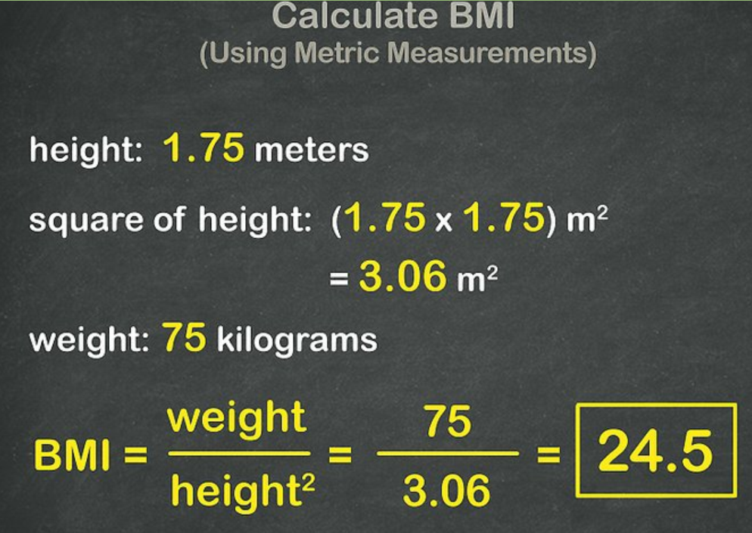

Departure Date Click here to enter a date. Return Date Click here to enter a date.

Mode of travel Choose an item. Do you smoke? Choose an item.

Age on date of departure Click here to enter text.

Are you intending to participate in hazardous pursuits (ski, bungee jumping, river rafting, etc) Choose an item.
If YES, what type of sport? Click here to enter text.

Have you previously submitted a claim in respect of your medical condition whilst overseas? Choose an item.
If YES: Date of claim Click here to enter a date.
Details of claim Click here to enter text.

Have you visited a doctor in the last 90 days? Choose an item.
If YES, date? Click here to enter a date.

Medical History
Please answer ‘Yes’ or ‘No’ to all questions in this section. If you answer ‘Yes” to any of the questions, please complete all details in that question.
- Have you ever had a blood clot, such as a Deep Vein Thrombosis (DVT or Pulmonary Embolism? Choose an item.
If YES: Date Click here to enter a date.
Reason for clot (e.g. pregnancy, after surgery, aeroplane journey) Click here to enter text.

- Have you ever been diagnosed with a chronic lung disease (including Emphysema and Chronic Bronchitis, Cbronchiectasis, COAD (Chronic Obstructive Airways Disease) or COPD (Chronic Obstructive Pulmonary Disease), Cystic Fibrosis, Asbestosis or Asthma)? Choose an item.
If YES: Name of condition? Click here to enter text.
Date you were last in Hospital/Emergency Department with this condition Click here to enter a date.
Do you require home oxygen therapy? Choose an item.
Will you require oxygen for the journey? Choose an item.

- Do you have Diabetes Mellitus? Choose an item.
If YES: Date of Diagnosis Click here to enter a date.
Currently controlled with (please select):
Diet only ☐
Insulin injections ☐
Insulin Pump ☐
Other medication Click here to enter text.
Do you have any resulting problems with your (please select):
Eyes ☐
Kidneys ☐
Legs ☐

- Do you take medication for Hypertension (High blood pressure)? Choose an item.
List medications Click here to enter text.

- Do you take any medication for Hypercholesterolemia (High Cholesterol)? Choose an item.
List medications Click here to enter text.

- Have you ever had Angina (Chest Pain)? Choose an item.
If YES: When was your last attack Click here to enter a date.
Frequency of attacks Click here to enter text.
What treatment do you take for it? Click here to enter text.

- Have you ever had a heart attack (myocardial infarct)? Choose an item.
If YES: Date of heart attack Click here to enter a date.

- Have you ever had coronary angiography, stents or bypass grafting (CABG)? Choose an item.
If YES: Date Click here to enter a date. Procedure Click here to enter text.
Have you experienced any angina since that procedure? Choose an item.

- Have you ever had a stroke (CVA) or mini-stroke (TIA)? Choose an item.
If YES: date Click here to enter a date.

- Have you ever been diagnosed with a heart arrhythmia such as atrial fibrillation? Choose an item.
If YES: Name of condition Click here to enter text.
Date of diagnosis Click here to enter a date.
List of medications Click here to enter text.

- Do you have a Pacemaker or AICD (internal defibrillator)? Choose an item.
If YES: Type of device inserted Click here to enter text.
Date of insertion Click here to enter a date.

- Do you take any other medication for your heart, or to thin your blood? Choose an item.
E.g. Warfarin (also known as Coumadin, Jantoven, Marevan, and Waran)
If YES: list medications Click here to enter text.

- Have you ever been diagnosed with epilepsy? Choose an item.
If YES: Have you experienced a seizure in the last 12 months? Choose an item.
Have there been any changes to your seizure medication in the last 12 months? Choose an item.

- Have you been hospitalised (including day surgery), or attended an Emergency Department in the past 24 months? Choose an item.
If YES: Please provide details: (if one to these attendances was for routine colonoscopy, please indicate whether the result was normal)
Date of Event Reason for attendance
Click here to enter a date. Click here to enter text.
Click here to enter a date. Click here to enter text.
Click here to enter a date. Click here to enter text.

- Please provide details of any other Pre-existing Condition not mentioned:
Medical condition Current medication/treatment
Click here to enter text. Click here to enter text.
Click here to enter text. Click here to enter text.
Click here to enter text. Click here to enter text.
Were any of these conditions newly diagnosed in the last 3 months? Choose an item.
If YES, please provide details
Click here to enter text.

Passenger Declaration:
All the answers given herewith are true, correct and complete. I have not withheld any information likely to affect my application for cover. I hereby authorise my doctor, hospital, clinic or any other person to provide Oojah Travel Protection any medical information (past and current). I agree not to be covered for any Pre-Existing condition unless disclosed in this form and Oojah Travel Protection has agreed to cover those conditions.

Privacy Policy
By completing this form, you give us your permission to process the information you provide. We will treat your personal information with caution and we have put reasonable security measures in place to protect it. You are welcome to request access to any of your personal information that we hold.

Name of applicant Click here to enter text.
Date of application Click here to enter a date.

